GRADE 7 ACCELERATED · UNIT 1  Reference Sheet  Equations and Inequalities — keep this in your binder | Name_________________  Period_______________

1. Rational Numbers in Three Forms
From | To | What you do | Example
fraction | decimal | divide the top by the bottom | 3/8 = 0.375
decimal | percent | multiply by 100 | 0.375 = 37.5%
percent | decimal | divide by 100 | 35% = 0.35
decimal | fraction | put it over 10, 100, 1000… then simplify | 0.35 = 35/100 = 7/20
repeating | fraction | If the repeat starts at the decimal point: 1 digit over 9, 2 over 99, 3 over 999 | 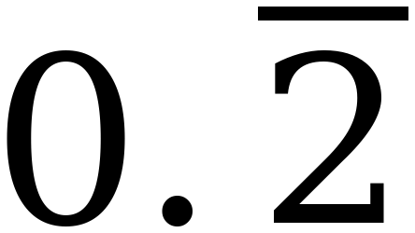 = 2/9, 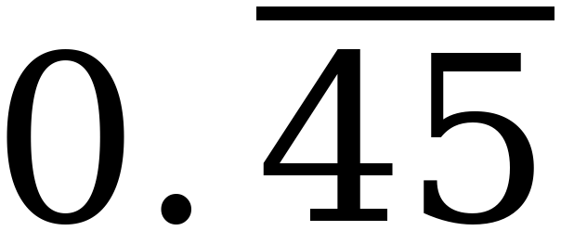 = 45/99 = 5/11

The ninths. 1/9 = 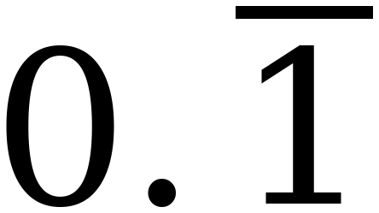, 2/9 = , 3/9 = 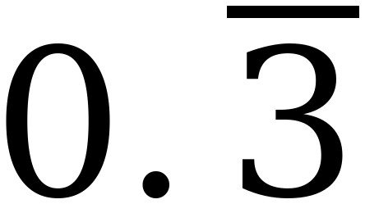, … 8/9 = 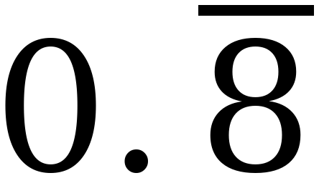. The numerator is the repeating digit.
Your calculator rounds. A TI-30XA has a ten-digit display. Enter 5 ÷ 9 and it shows 0.555555556. The exact value is 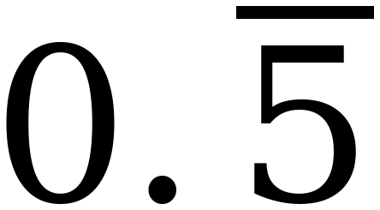 — the last digit on the screen has been rounded up. Enter 6 ÷ 9 and it shows 0.666666667 for the same reason.
2. Solving an Equation
Properties of equality. Whatever you do to one side, do to the other. You may add, subtract, multiply or divide both sides by the same number. You may not divide by zero.
Distributive property. a(b + c) = a·b + a·c. The factor outside multiplies EVERY term inside, including the second one.
Two ways to start a(b + c) = d. Distribute the a first, or divide both sides by a first. Both give the same answer. If a divides d evenly, dividing first is usually shorter.
The line that matters. Distributing rewrites ONE side and changes nothing else. The properties of equality are operations on BOTH sides. They are not the same move.
3. Writing an Equation from a Situation
1. DEFINE | Write a sentence saying what the letter stands for. “t = the number of hours the tank has been draining.” “t = hours” is not a definition.
2. WRITE | Put the numbers in place: p x + q = r
3. SOLVE | Inverse operations, both sides, one step at a time.
4. INTERPRET | Answer the question in a sentence, with units.

- p is almost always a RATE — per hour, per item, per month.
- q is almost always a STARTING VALUE — charged once, no matter what.
- If the rate takes something away, p is negative: 12,340 − 780t = 5,125.
- When a whole group repeats, use parentheses: 6(3.79 + m) = 37.56.
- Ask which number changes when the unknown changes. That number is p.
4. Percents in a Situation
commission — a percent of sales, paid on top of a salary
discount — a percent taken off a price
Write the percent as a decimal first. 10% = 0.10. 3% = 0.03. 20% = 0.20.
20% OFF means you pay 80%. Multiply by 0.80, not by 0.20. 0.20p is what you SAVE; 0.80p is what you PAY.
Name the three quantities. If someone earns $350 a week plus 10% commission and takes home $800, then sales = $4,500, commission = $450 and total earnings = $800. Read which one the question asked for.
5. Inequalities: Words into Symbols
Words | Symbol | Example
at most, no more than, maximum | ≤ | at most $25 → total ≤ 25
at least, no less than, minimum | ≥ | at least 170 shirts → shirts ≥ 170
fewer than, less than, under | < | fewer than 12 people → people < 12
more than, greater than, over | > | more than 3 hours → hours > 3

At most and at least INCLUDE the number. Fewer than and more than do not.
6. Solving an Inequality
Everything you know about equations still works. One rule is added.
- Add or subtract on both sides — nothing changes.
- Multiply or divide by a POSITIVE number — nothing changes.
- Multiply or divide by a NEGATIVE number — the symbol REVERSES.
Why. 4 < 6 is true. Multiply both sides by −1 and you get −4 > −6, because −4 sits to the RIGHT of −6 on the number line. Negatives reverse order.
Distributing a negative does NOT reverse anything. −6(8 − x) becomes −48 + 6x. That is a rewrite of one side, not an operation on both. Count the times you MULTIPLY OR DIVIDE BOTH SIDES by a negative — that is how many times the symbol moves. Two reversals put it back where it started.
Check with two values. Pick one value inside your answer — it must make the inequality true. Pick one outside — it must make it false. Do not test the BOUNDARY: it satisfies both x ≤ b and x ≥ b, so it is the one value that cannot tell you whether you reversed.
7. Graphing a Solution Set
- OPEN circle for < and >. The boundary is not a solution.
- CLOSED circle for ≤ and ≥. The boundary is a solution.
- Rewrite with the letter on the LEFT before you graph. −18 ≥ y becomes y ≤ −18.
- Shade toward the numbers that work. If you are unsure, test 0 — it is the easiest number to substitute, unless 0 is your boundary, in which case pick 1 or −1.
- The arrow points where the solutions are, not where the symbol appears to point.
- If the boundary is not a whole number, place the circle between the two integers it falls between and say which two.
8. Turning an Answer Back into Real Things
- A MAXIMUM (≤) rounds DOWN. Going up would break the limit.
- A MINIMUM (≥) rounds UP. Going down would not be enough.
- Money rounds to the cent, and the same rule decides which way.
- Sometimes the answer is already a whole thing and nothing changes.
The check that always works. Substitute your rounded answer back into the original. If the statement comes out false, you rounded the wrong way. Example: at least 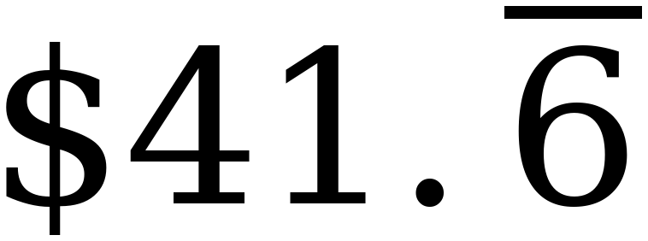 a month rounds UP to $41.67, because 6 × $41.66 = $249.96 falls short.
9. Vocabulary
at least — no less than — the value itself is allowed; ≥
at most — no more than — the value itself is allowed; ≤
boundary value — the number where the two sides of an inequality are exactly equal
closed circle — the boundary IS a solution — used for ≤ and ≥
coefficient — the number multiplying the variable
commission — a percent of sales, paid on top of a salary
constant — a quantity that stays the same no matter what
discount — an amount or percent taken off a price
distributive property — a(b + c) = a·b + a·c — the factor outside multiplies every term inside
equivalent — having the same value, written a different way
inequality — a statement that two expressions are not necessarily equal
maximum — the largest value a quantity is allowed to take
minimum — the smallest value a quantity is allowed to take
open circle — the boundary is NOT a solution — used for < and >
rate — an amount per unit — per hour, per item, per month
rational number — a number that can be written as a fraction of two integers
reciprocal — a fraction turned upside down; multiplying by it undoes multiplying by the original
repeating decimal — a decimal whose digits repeat forever, written with a bar over the repeating part
reverse — to turn the inequality symbol the other way round
solution — a value that makes a statement true when you substitute it
solution set — every value that makes an inequality true
terminating decimal — a decimal that stops
variable — a letter standing for the quantity that changes
10. Why This Unit Holds Two Grades at Once
You are in an accelerated course. You are learning a year of grade 7 mathematics and a year of grade 8 mathematics at the same time. Every benchmark in this unit is required course content — it is being taught to you for the first time here, and none of it is review.
The grade 7 half. Rational numbers in three forms, and two-step equations. These come first, and the rest of the year stands on them: you cannot solve a multi-step equation later this year, or work a percent, a rate or a slope problem anywhere on the Grade 8 FAST, without them. Sections 1 through 4 of this sheet are that half.
The grade 8 half. Solving two-step inequalities, and representing the solutions algebraically and graphically. That is reported on the Grade 8 FAST under Algebraic Reasoning. Sections 5 through 8 are that half.
Calculators. The Grade 8 FAST gives you an on-screen scientific calculator for the whole test. Not every question needs one. The questions in this unit are built so that a calculator does the arithmetic and you still do the thinking — it will not tell you which operation to undo first, or which way an inequality points after you divide by a negative.
The reference sheet you get on test day gives you the slope formula, the Triangle Inequality Theorem, the Triangle Sum Theorem and a table of conversions. It gives you nothing from this unit, and there is no key box. Everything on this page has to be in your head.

